**An/A IOMP/MAJOR PROJECT**

**on**

**GESTURE AND SIGN LANGUAGE TRANSLATOIN**

Submitted to

JAWAHARLAL NEHRU TECHNOLOGICAL UNIVERSITY, HYDERABAD

In partial fulfilment of the requirement for the award of the degree of

**BACHELOR OF TECHNOLOGY**

**in**

**ELECTRONICS AND COMMUNICATION ENGINEERING**

**By**

|  |  |
| --- | --- |
| **MOHAMMED SUFIYAN SHAREEF** | **217Y1A6657** |
| **KASALA LOKESH** | **217Y1A6626** |
|  |  |

**Under the Guidance of**

Mrs.K.SWAPNA, Associate professor



**DEPARTMENT OF COMPUTER SCIENCE ENGINEERING, ARTIFICIAL INTELIGENCE AND MACHINE LEARNING**



Augusr,2024



**DEPARTMENT OF COMPUTER SCIENCE ENGINEERING, ARTIFICIAL INTELIGENCE AND MACHINE LEARNING**

Date: 9/August/ 2024

**CERTIFICATE**

This is to certify that the project work entitled “**GESTURE AND SIGN LANGUAGE TRANSLATION**” work done by **MOHAMMED SUFIYAN SHAREEF(217Y1A6657), KASALA LOKESH(217Y1A6626)** student(s) of Department of Computer science and engineering, Artificial Intelligence and Machine Learning, is a record of Bonafede work carried out by the member(s) during a period from January, 2024 to August, 2024 under the supervision of Mrs.K.SWAPNA . This project is done as a fulfilment of obtaining Bachelor of Technology Degree to be awarded by Jawaharlal Nehru Technological University Hyderabad, Hyderabad.

The matter embodied in this project report has not been submitted by me/us to any other university for the award of any other degree.

|  |  |  |
| --- | --- | --- |
|  |  |  |
| MOHAMMED SUFIYAN SHAREEF |  | KASALA LOKESH |

This is to certify that the above statement made by the candidate(s) is correct to the best of my knowledge.

Date: 9/Augus/2024 Mrs.K.SWAPNA

The Viva-Voce Examination of above student(s), has been held on………………………

|  |  |
| --- | --- |
| Head of the Department | External Examiner |
|  |  |
| Principal/Director | |



**DEPARTMENT OF COMPUTER SCIENCE ENGINEERING, ARTIFICIAL INTELIGENCE AND MACHINE LEARNING**

**DECLARATION**

We hereby declare that the results embodied in the dissertation entitled " GESTURE AND SIGN LANGUAGE TRANSLATION." has been carried out by us together during the academic year 2023-24 as a partial fulfilment of the award of the B. Tech degree in computer science and engineering (AI&ML) from MLRITM. We have not submitted this report to any other university or organization for the award of any other degree.

Student Name Roll No  
Mohammed Sufiyan shareef 217Y1A6657  
kasala Lokesh 217Y1A6626

.

MINI PROJECT REPORT (2020-2024) Dept of CSE(AI&ML), MLRITM

**ACKNOWLEDGEMENTS**

I/we would like to express my sincere gratitude to my guide **Mrs.K.SWAPNA, Associate professor**, CSM, for his/her excellent guidance and invaluable support, which helped me accomplish the B.Tech (CSM) degree and prepared me to achieve more life goals in the future. His total support of my dissertation and countless contributions to my technical and professional development made for a truly enjoyable and fruitful experience. Special thanks are dedicated for the discussions we had on almost every working day during my project period and for reviewing my dissertation.

I/we am very much grateful to my project coordinator. **DR.HUSSAIN SHARIF, professor,** CSM, MLRITM, Dundigal, Hyderabad, who has not only shown utmost patience, but was fertile in suggestions, vigilant in directions of error and has been infinitely helpful.

I/we am extremely grateful to **Dr.RAVI PRASAD, HOD & professor**, MLRITM, Dundigal, Hyderabad, for the moral support and encouragement given in completing my project work.

I/we wish to express deepest gratitude and thanks to **Dr. R. Murali Prasad, Principal, and Dr. P. Sridhar, Director** for their constant support and encouragement in providing all the facilities in the college to do the project work.

I/we would also like to thank all our faculties, administrative staff and management of MLRITM, who helped me to completing the mini project.

On a more personal note, I thank my **beloved parents and friends** for their moral support during the course of our project.

**Vision of MLRITM**

* To be the fountainhead in producing highly skilled, globally competent engineers.
* Producing quality graduates trained in the latest software technologies and related tools and striving to make India a world leader in software products and services**.**

**Mission of MLRITM**

* To provide a learning environment that inculcates problem solving skills, professional, ethical responsibilities, lifelong learning through multi modal platforms and prepares students to become successful professionals.
* To establish an industry institute Interaction to make students ready for the industry.
* To provide exposure to students on the latest hardware and software tools.
* To support the faculty to accelerate their learning curve to deliver excellent service to students.

**Vision of the CSM**

* To produce globally competent graduates to meet the modern challenges through contemporary knowledge and moral values committed to build a vibrant nation.

**Mission of the CSM**

* To create an academic environment, which promotes the intellectual and professional development of students and faculty.
* To impart skills beyond university prescribed to transform students into a wellrounded IT professional**.**

To nurture the students to be dynamic, industry ready and to have multidisciplinary skills including e-learning, blended learning and remote testing as an individual and as a team**.**

MINI PROJECT REPORT (2021-2025) Dept of CSE(AI&ML), MLRITM

**PROGRAM OUTCOMES (POs)**

1. Engineering Knowledge: Apply the knowledge of mathematics, science, engineering fundamentals, and an engineering specialization to the solution of complex engineering problems.
2. Problem Analysis: Identify formulate, review research literature, and analyze complex engineering problems reaching substantiated conclusions using first principles of mathematics, natural sciences, and engineering sciences.
3. Design/Development of solutions: Design solutions for complex engineering problems and design system components or processes that meet the specified needs with appropriate consideration for the public health and safety, and the cultural, societal, and environmental considerations.
4. Conduct Investigations of Complex problems: Use research-based knowledge and research methods including design of experiments, analysis and interpretation of data, and synthesis of the information to provide valid conclusions.
5. Modern Tool Usage: Create select, and, apply appropriate techniques, resources, and modern engineering and IT tools including prediction and modeling to complex engineering activities with an understanding of the limitations.
6. The Engineer and Society: Apply reasoning informed by contextual knowledge to societal, health, safety. Legal und cultural issues and the consequent responsibilities relevant to professional engineering practice.
7. Environment and Sustainability: Understand the impact of the professional engineering solutions in societal and environmental contexts and demonstrate the knowledge of, and need for sustainable development.
8. Ethics: Apply ethical principles and commit to professional ethics and responsibilities and norms of the engineering practice.
9. Individual and Team Work: Function effectively as an individual, and as a member or leader in diverse teams and in multidisciplinary settings.
10. Communication: Communicate effectively on complex engineering activities with the engineering community and with society at large, such as, being able to comprehend and write effective reports and design documentation, make effective presentations, and give and receive clear instructions.
11. Project Management and Finance: Demonstrate knowledge and understanding of the engineering and management principles and apply these to one's own work, as a member and leader in a team, to manage projects and in multidisciplinary environments.

MINI PROJECT REPORT (2021-2025) Dept of CSE(AI&ML), MLRITM

1. Life-Long Learning: Recognize the need for, and have the preparation and ability to engage in independent and life-long learning in the broadest context of technological change

**PROGRAM SPECIFIC OUTCOMES (PSOS)**

1. PSO1: An ability to analyze the common business functions to design and develop appropriate Information Technology solutions for social upliftments.
2. PSO2: Shall have expertise on the evolving technologies like Python, Machine Learning, Deep learning, IOT, Data Science, Full stack development, Social Networks, Cyber Security, Mobile Apps, CRM, ERP, Big Data, etc.

**PROGRAM EDUCATIONAL OBJECTIVES (PEOs)**

1. PEO1: Graduates will have successful careers in computer related engineering fields or will be able to successfully pursue advanced higher education degrees.
2. PEO2: Graduates will try and provide solutions to challenging problems in their profession by applying computer engineering principles.
3. PEO3: Graduates will engage in life-long learning and professional development by rapidly adapting to the changing work environment.
4. PEO4: Graduates will communicate effectively, work collaboratively and exhibit high levels of professionalism and ethical

**PROJECT OUTCOMES**

1. P1: To accurately recognize and translate American Sign Language (ASL) gestures using a real-time webcam feed.
2. P2: To provide high-confidence predictions of hand gestures and signs with visual feedback.
3. P3: To enable the adaptive inclusion of new gestures and signs into the recognition model without retraining the entire system.
4. P4: To create a user-friendly interface that can be used by individuals for learning or communication through sign language.

**Confidence Levels** LOW-1 MEDIUM-2 HIGH-3

MINI PROJECT REPORT (2021-2025) Dept of CSE(AI&ML), MLRITM

**TABLE OF CONTENTS**

|  |  |  |  |  |
| --- | --- | --- | --- | --- |
|  | | | | **Page No.** |
| *Certificate* | | | | *ii* |
| *Declaration.* | | | | *iii* |
| *Acknowledgements* | | | | *iv* |
| *Vision and mission.* | | | | *v* |
| *program outcomes. PO’s. , PSO’s , PEO’s* | | | | *vi* |
| *Project outcomes* | | | | *vii* |
| *Table of Contents* | | | | *viii* |
| *List of Figures* | | | | *xi* |
| *List of Abbreviations* | | | | *xii* |
| *List of Tables* | | | | *xii* |
| *Abstract* | | | | *xiii* |
| **Chapter 1: Introduction** | | | | 1-7 |
|  | 1.1 | Background | | 1 |
|  | 1.2 | Objectives | | 2 |
|  |  | 1.2.1 | Primary Objectives | 2 |
|  |  | 1.2.2 | Secondary Objectives | 3 |
|  | 1.3 | Scope | | 4 |
|  |  | 1.3.1 | inclusions and Exclusions | 4 |
|  | 1.4 | Methodology | | 5 |
| **Chapter 2: Literature Survey** | | | | 8-13 |
|  | 2.1 |  | Introduction to Gesture Recognition | 9 |
|  | 2.2 |  | Previous Work | 9 |
|  |  | 2.2.1 | Academic Research | 9 |
|  |  | 2.2.2 | Industry Applications | 11 |
|  | 2.3 |  | Technologies Used | 12 |
|  | 2.4 |  | Challenges and Limitations | 12 |
|  | 2.5 |  | Summary | 13 |
| **Chapter 3: Problem Analysis** | | | | 14-21 |
|  | 3.1 |  | Problem Statement | 14 |
|  | 3.2 |  | Analysis of Current Systems | 15 |
|  |  | 3.2.1 | Overview of Existing Technologies | 15 |
|  |  | 3.2.2 | Challenges in existing system. | 15 |
|  |  | 3.2.3 | Successes and limitations. | 16 |
|  | 3.3 |  | System Requirements | 17 |
|  |  | 3.3.1 | Functional Requirements | 17 |
|  |  | 3.3.2 | Non-Functional Requirements | 17 |
|  | 3.4 | Proposed Solution | | 18 |
|  | 3.4.1 | System Architecture. | | 18 |
| **Chapter 4: System Design and Implementation**. | | | | 22-25 |
|  | 4.1 |  | Introduction to system design. | 22 |
|  | 4.2 |  | Data collection and preparation. | 22 |
|  | 4.3 |  | Feature extraction with mediocre. | 23 |
|  | 4.4 |  | Model training and development. | 24 |
|  | 4.5 |  | Real time recognition and processing. | 25 |
| **Chapter 5: Development of ANN architecture** | | | | 26-31 |
|  | 5.1 |  | Data collection. | 26 |
|  |  | 5.1.1 | Objectives. | 26 |
|  |  | 5.1.2 | Process. | 26 |
|  | 5.2 |  | Data processing. | 28 |
|  |  | 5.2.1 | Objective. | 28 |
|  |  | 5.2.2 | Process. | 28 |
|  | 5.3 |  | Model training. | 29 |
|  |  | 5.3.2 | Objective. | 29 |
|  |  | 5.3.2 | Process. | 29 |
|  | 5.4 |  | Real-time recognition. | 31 |
|  |  | 5.4.1 | Objective | 31 |
|  |  | 5.4.2 | process. | 31 |
| **Chapter 6. Testing and Evaluation.** | | | | 32-34 |
|  | 6.1 |  | Testing methodology. | 32 |
|  | 6.2 |  | Evaluation matrix. | 32 |
|  | 6.3 |  | Challenges and solutions. | 33 |
|  |  | 6.3.1 | Technical challenges. | 33 |
|  |  | 6.3.2 | Practical challenges. | 33 |
|  | 6.4 |  | Future work and enhancements | 33 |
|  |  | 6.4.1 | Expansion of gesture library. | 33 |
|  |  | 6.4.2 | Improved accuracy and performance. | 34 |
|  |  | 6.4.3 | User experience enhancement.. | 34 |
|  |  | 6.4.4 | Integration with other technologies | 34 |
| **Chapter 7:ethical consideration and Social Impact.** | | | | 35--35 |
|  | 7.1 |  | Accessibility and inclusivity | 35 |
|  | 7.2 |  | Societal impact. | 35 |
| **Chapter 8. Case Study and Applications.** | | | | 36-36 |
|  | 8.1 |  | Educational applications. | 36 |
|  | 8.2 |  | Workplace applications. | 36 |
|  | 8.3 |  | healthcare applications. | 36 |
| **Conclusion and Summary** | | | | 37-38 |
|  |  |  | recap of system design and implementation. | 37 |
|  |  |  | Inside from testing and evaluation | 37 |
|  |  |  | addressing challenges and future directions. | 37 |
|  |  |  | Ethical and social Implications | 38 |
|  |  |  | Final reflection | 38 |
| ***References****:* *MediaPipe Documentation,* *OpenCV Documentation, TensorFlow* | | | | 39 |

**LIST OF FIGURES**

|  |  |  |
| --- | --- | --- |
| **Figure No.** | **Name of the Figure** | **Page No.** |
| Figure 1.1 | hand signs in ASL dataset | 6 |
| Figure 1.2 | Table and representation of points system to represent a hand in media pipe | 7 |
| Figure 1.3 | Representation of how this program will read the hands | 7 |
| Figure 3.1 | Visible representation of solution | 21 |
| Figure 4.1 | data collection using OpenCV | 22 |
| Figure 4.2 | process of feature extraction using mediapipe | 23 |
| Figure 4.3 | landmark points on hand | 23 |
| Figure 4.4 | model training and layers in model | 24 |
| Figure 4.5 | real time prediction | 25 |
| Figure 5.1 | code for data collection | 27 |
| Figure 5.2 | code for data processing | 29 |
| Figure 5.3 | code for model training and preparation | 30 |
| Figure 5.4 | code for real-time recognition | 31 |
|  |  |  |
|  |  |  |

**LIST OF ABBREVIATIONS**

|  |  |
| --- | --- |
| Abbreviation | Description. |
|  |  |
|  |  |
|  |  |
|  |  |
|  |  |
|  |  |
|  |  |
|  |  |
|  |  |
|  |  |
|  |  |

**LIST OF TABLES**

|  |  |  |
| --- | --- | --- |
| **Table No.** | **Name of the Table** | **Page No.** |
|  |  |  |
|  |  |  |
|  |  |  |
|  |  |  |
|  |  |  |
|  |  |  |
|  |  |  |

**ABSTRACT**

In recent years, the development of real-time gesture and sign language translation systems has gained significant attention due to their potential to enhance communication for individuals with hearing impairments. This study presents a novel gesture and sign language translation model designed to facilitate seamless interaction between users and technology. The model leverages advanced computer vision and machine learning techniques, including MediaPipe for hand landmark detection, OpenCV for image processing, and TensorFlow for deep learning.

The system is trained on a comprehensive dataset of American Sign Language (ASL) hand signs representing numbers 0-9, letters A-Z, and common gestures such as 'thumbs up,' 'thumbs down,' 'hi,' 'stop,' and 'peace.' By utilizing a webcam for live data acquisition, the model dynamically captures and processes hand gestures in real-time. This approach allows for continuous learning and adaptation to new gestures, ensuring the system remains up-to-date and responsive.

The model's architecture comprises several key stages: data collection, preprocessing, model training, and real-time recognition. The data collection phase involves capturing and labelling hand sign images, followed by feature extraction to prepare the data for training. The model is then trained to recognize and classify gestures with high accuracy. During real-time operation, the system analyses live webcam feed to identify gestures and display corresponding translations with confidence levels.

The proposed model aims to bridge communication gaps by providing an intuitive and accessible tool for translating gestures into meaningful text, thereby contributing to improved interaction and understanding within diverse environments.

**CHAPTER 1**

**INTRODUCTION**

The development of technology has enabled innovative solutions for communication barriers, particularly for individuals who rely on sign language. This project aims to create a real-time gesture and sign language translation system that leverages computer vision and machine learning. By utilizing tools such as MediaPipe, OpenCV, and TensorFlow, the system will recognize and translate American Sign Language (ASL) and specific hand gestures into text, providing a bridge for communication between different communities. The project focuses on real-time processing, accuracy, and the ability to easily adapt and expand the system to include new gestures.

**1.1 Background**

The quest to break communication barriers between different communities has been a long-standing challenge. For individuals who are deaf or hard of hearing, American Sign Language (ASL) serves as a primary mode of communication. However, the general population's lack of familiarity with ASL can result in significant communication gaps. The necessity for effective communication tools is critical, not only in everyday interactions but also in essential services such as healthcare, education, and public safety.

Historically, sign language interpretation has relied heavily on human interpreters. While effective, this solution is not always practical or accessible. In emergency situations or areas with a limited number of interpreters, the ability to communicate efficiently can be compromised. Written text, another alternative, often fails to capture the full nuance of sign language, which includes facial expressions and body language as integral components.

The advent of computer vision and machine learning technologies has provided new opportunities to address these challenges. Early attempts at gesture recognition systems were hampered by limited computational power and inadequate algorithms. However, advancements in neural networks and deep learning have revolutionized this field, enabling more accurate and sophisticated systems. MediaPipe, OpenCV, and TensorFlow are at the forefront of these technologies, offering tools that facilitate the detection and interpretation of hand gestures in real-time.

**MediaPipe** provides a framework for building multimodal machine learning pipelines, including the detection of hand landmarks. Its ability to process high-fidelity hand tracking is crucial for recognizing subtle differences in ASL gestures. **OpenCV** (Open Source Computer Vision Library) supports a wide array of image processing operations, essential for preprocessing and enhancing the visual data captured by cameras. **TensorFlow**, a comprehensive machine learning platform, allows for the development and training of complex models that can accurately classify gestures.

This project is set against the backdrop of a growing recognition of the importance of inclusivity and accessibility. As society becomes more aware of the need for equitable access to communication tools, the development of a real-time gesture and sign language translation system represents a significant step forward. By providing immediate translation of ASL into text, this project aims to enhance understanding and interaction between different communities, thereby promoting inclusivity and reducing social barriers.

**1.2 Objectives**

**1.2.1 Primary Objectives**

The primary objectives of this project are designed to establish a robust foundation for gesture and sign language recognition systems:

* **Development of a Real-Time Recognition System:** The project’s cornerstone is a real-time system that can accurately recognize ASL signs and a set of predefined gestures. The choice of signs includes numbers 0-9 and letters A-Z, providing a broad basis for communication. Additionally, common gestures like 'thumbs up' and 'peace' are included due to their frequent use in everyday interactions. The real-time aspect is crucial; the system must process and recognize gestures instantaneously to facilitate natural and fluid communication.
* **Machine Learning Model Implementation:** At the heart of the system is a machine learning model trained to classify gestures based on hand landmarks. The model needs to handle a wide range of variations, including different hand shapes, sizes, and movements. The complexity of ASL, which often involves rapid and nuanced gestures, necessitates a highly accurate model. Techniques such as data augmentation and regularization may be employed to enhance the model's robustness and generalizability.
* **Real-Time Feedback Mechanism:** A key feature of the system is the real-time feedback mechanism, which displays the recognized gesture and the associated confidence level. This feedback is critical for users, especially in learning environments where immediate correction can aid in understanding and improving gesture accuracy. The confidence level provides an indication of the system's certainty, which can help users gauge the reliability of the recognition at any given moment.

**1.2.2 Secondary Objectives**

Beyond the core functionality, the project includes secondary objectives that aim to enhance the system’s usability and adaptability:

* **User-Friendly Interface for Data Collection:** The development of an intuitive interface for data collection is vital. Users, including researchers and practitioners, should be able to add new gestures to the dataset easily. This capability ensures the system's scalability, allowing for the continuous expansion of recognized gestures without requiring extensive technical expertise.
* **Adaptability to New Gestures:** The system's architecture should support the addition of new gestures with minimal disruption. This involves designing the model to accommodate new classes (gestures) and retraining it efficiently. The use of transfer learning techniques, where a pre-trained model is fine-tuned with new data, can be an effective strategy for this purpose.
* **Handling Diverse Conditions:** Recognizing gestures accurately in diverse conditions, such as varying lighting, backgrounds, and user demographics, is a challenging yet important goal. The system must be robust enough to perform reliably across different environments. This includes addressing issues like changes in illumination, which can affect the visibility of hand landmarks, and ensuring that the model generalizes well across different skin tones and hand shapes.

**1.3 Scope**

**1.3.1 Inclusions and Exclusions**

**Inclusions:**

* **Recognition of ASL Signs for Numbers and Letters:** The system is designed to cover the fundamental aspects of ASL, including numbers and letters, which form the basis for spelling out words and conveying essential information.
* **Recognition of Specific Gestures:** The inclusion of specific gestures, such as 'thumbs up' and 'stop,' addresses common expressions that are useful in both casual and formal communication. These gestures are chosen for their universal applicability and ease of recognition.
* **Real-Time Processing Using a Live Webcam Feed:** The choice to use a live webcam feed for real-time processing underscores the project's emphasis on practical, everyday usability. The system's ability to operate in real-time is essential for dynamic interactions, such as conversations and live presentations.
* **Adaptability for New Gestures:** The system's architecture is designed to be extensible, allowing for the addition of new gestures. This flexibility is crucial for keeping the system relevant and up-to-date as new gestures emerge or as the system is adapted for different contexts.

**Exclusions:**

* **Facial Expression Recognition:** While facial expressions are an important aspect of sign language, this project focuses solely on hand gestures. Incorporating facial recognition would require additional computational resources and specialized techniques, which are beyond the scope of this project.
* **Voice-to-Sign Translation:** The project does not include translating spoken language into sign language. Such a feature would require a different set of technologies, including speech recognition and natural language processing, which are not covered in this study.
* **Recognition of Other Sign Languages:** The system is tailored specifically for ASL. The recognition of other sign languages would involve significant modifications, as different sign languages have unique signs and grammatical rules.
* **Extensive Testing Under Varying Environmental Conditions:** While the system will be evaluated under different conditions, extensive testing across all possible variables (e.g., extreme lighting, diverse backgrounds) is outside the project's current scope. Future work may include more comprehensive environmental testing.

**1.4 Methodology**

The methodology outlines the systematic approach taken to develop and implement the gesture and sign language recognition system. Each phase is critical for ensuring the system's accuracy, reliability, and usability.

1. **Data Collection:** The first step involves gathering a comprehensive dataset of ASL signs and gestures. Using a high-resolution webcam, the system captures multiple images and videos of each gesture from various angles and under different conditions. MediaPipe is utilized for detecting hand landmarks, which provide the primary features for gesture recognition. The data collection process is meticulous, ensuring that the dataset is diverse and representative of different hand shapes, sizes, and movements.
2. **Data Preprocessing:** After collection, the data undergoes extensive preprocessing. This phase includes normalizing the coordinates of the hand landmarks to account for variations in distance from the camera and hand orientation. Data augmentation techniques, such as rotation, scaling, and flipping, are applied to enhance the dataset's diversity and improve the model's robustness. Preprocessing also involves filtering out noise and irrelevant data, ensuring that the inputs to the model are clean and consistent.
3. **Model Training:** The core of the system lies in the training of a convolutional neural network (CNN) designed to classify gestures. The model architecture is carefully chosen to balance depth and computational efficiency, ensuring that it can handle the complexity of ASL while remaining responsive in real-time applications. The training process involves splitting the data into training, validation, and test sets, with hyperparameter tuning and regularization techniques applied to optimize performance. Transfer learning may also be employed, leveraging pre-trained models to accelerate training and improve accuracy.
4. **Real-Time Recognition:** The trained model is integrated into a real-time recognition system. The system continuously processes the live webcam feed, extracting hand landmarks and feeding them into the model. The model's output is a classification of the gesture along with a confidence score, which is displayed to the user. The system is optimized for low latency, ensuring that the recognition process is fast and responsive, enabling smooth and natural interactions.
5. **System Testing and Evaluation:** The final phase involves comprehensive testing and evaluation. The system's accuracy is assessed using metrics such as precision, recall, and F1 score, ensuring that it performs well across a wide range of gestures and conditions. User experience testing is also conducted to gather feedback on the system's usability, responsiveness, and overall effectiveness. This feedback informs iterative improvements, including refining the model, enhancing the user interface, and expanding the dataset.

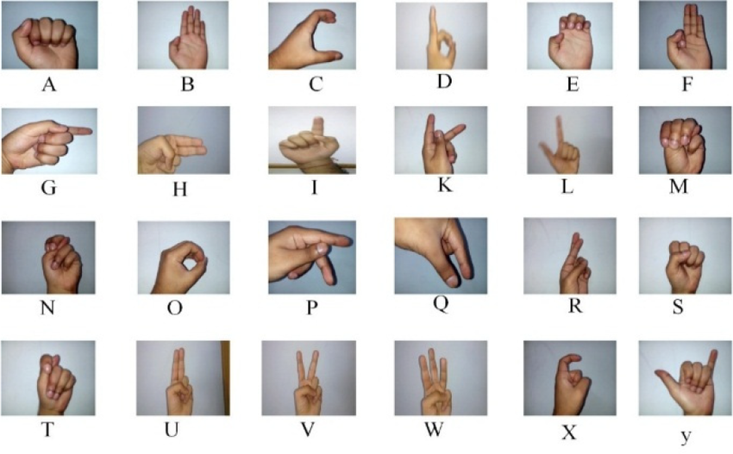

**Figure 1.1** hand signs in ASL dataset.

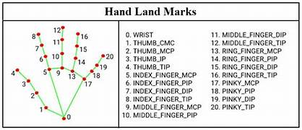

**Figure 1.2** Table and representation of points system to represent a hand in media pipe

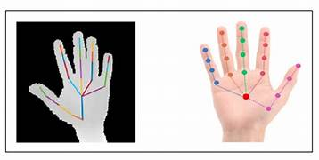

**FIGURE 1.3**  Representation of how this program will read the hands

**CHAPTER 2**

**LITERATURE SURVEY**

Gesture recognition has seen substantial progress from its early days to the sophisticated systems available today. Initially, gesture recognition systems relied on rule-based methods that used predefined gestures and simple pattern matching techniques. These early systems were limited in their ability to handle variations in hand shapes and movements.

With the advent of machine learning, particularly deep learning, the field has experienced significant advancements. Modern gesture recognition systems often utilize Convolutional Neural Networks (CNNs) to analyze and classify hand gestures with high accuracy. CNNs are particularly effective at learning complex patterns and features from large datasets, enabling systems to recognize a wide range of gestures and adapt to different users and environments.

A key technological advancement in this domain is the use of frameworks like MediaPipe, which provides tools for accurate hand landmark detection. MediaPipe's ability to detect and track hand landmarks in real-time has been instrumental in improving the precision and responsiveness of gesture recognition systems. OpenCV, an open-source computer vision library, complements this by offering robust image processing capabilities, while TensorFlow, a popular machine learning framework, supports the development and training of complex models for gesture classification.

Industry applications, such as Microsoft Kinect and Leap Motion, have demonstrated the practical utility of gesture recognition in interactive gaming, virtual reality, and other areas. These systems use depth sensors and cameras to capture detailed hand movements and translate them into digital commands. However, they also highlight ongoing challenges, including variations in user gestures, environmental conditions, and the need for real-time processing.

This project aims to address these challenges by leveraging the latest advancements in gesture recognition technology. By combining MediaPipe for hand landmark detection, OpenCV for image processing, and TensorFlow for model training, the project seeks to develop a real-time gesture and sign language translation system that is both accurate and adaptable to new gestures and conditions.

**2.1 Introduction to Gesture Recognition**

Gesture recognition is a branch of computer vision that involves the interpretation of human gestures through the use of algorithms and machine learning models. It serves as a natural interface for human-computer interaction (HCI), allowing users to communicate with digital devices through hand and body movements. The recognition and interpretation of gestures can be achieved through various methods, ranging from traditional rule-based approaches to sophisticated machine learning techniques.

The complexity of gesture recognition lies in the diversity of gestures and the variability in how they are performed. Factors such as hand shape, size, orientation, and movement speed can all influence the accuracy of recognition systems. Additionally, environmental conditions such as lighting and background clutter can further complicate the task. Gesture recognition systems have applications across numerous fields, including virtual reality (VR), augmented reality (AR), gaming, robotics, and assistive technologies for people with disabilities.

Historically, gesture recognition began with simple static pose recognition, where the system could identify specific hand shapes in a fixed position. As technology evolved, dynamic gesture recognition, which involves tracking movements over time, became possible. This progression has enabled more natural and intuitive interactions, making gesture recognition a vital component in the development of immersive and accessible technologies.

**2.2 Previous Work**

**2.2.1 Academic Research**

**Early Developments:** The initial research in gesture recognition was dominated by rule-based systems. These systems relied on predefined templates and geometric models to identify gestures. For instance, simple rules such as "if fingers are extended, it’s an open hand" were used to classify gestures. While straightforward, these methods were limited in their ability to handle the variability inherent in human gestures. They often struggled with occlusions, changes in viewpoint, and variations in hand shapes.

**Image Processing Techniques:** With advancements in image processing, researchers began using feature extraction methods such as edge detection, contour extraction, and skin color segmentation to identify hand regions. Techniques like Histogram of Oriented Gradients (HOG) and Scale-Invariant Feature Transform (SIFT) became popular for extracting meaningful features from hand images. These features were then used in combination with classifiers like Support Vector Machines (SVMs) to recognize gestures. Although these methods improved recognition accuracy, they still required significant manual feature engineering and were sensitive to lighting conditions.

**Machine Learning and Deep Learning:** The introduction of machine learning brought significant improvements to gesture recognition. Machine learning models, particularly Convolutional Neural Networks (CNNs), revolutionized the field by automatically learning hierarchical features from raw data. CNNs, with their ability to capture spatial hierarchies in images, became the go-to approach for static and dynamic gesture recognition.

In more recent years, the use of Recurrent Neural Networks (RNNs), particularly Long Short-Term Memory (LSTM) networks, has gained traction for dynamic gesture recognition. RNNs are well-suited for sequence data, making them ideal for tasks that involve temporal dependencies, such as recognizing sequences of hand movements in sign language. Hybrid models combining CNNs and RNNs have also been explored, leveraging CNNs for spatial feature extraction and RNNs for temporal pattern recognition.

**Multimodal Approaches:** Beyond visual cues, multimodal approaches have been investigated, incorporating audio, depth, and motion sensors to enhance recognition accuracy. For instance, using depth sensors like Microsoft Kinect can provide additional information about the distance and position of hands, improving gesture differentiation. These multimodal systems can significantly enhance robustness, especially in complex environments where visual data alone may be insufficient.

**2.2.2 Industry Applications**

**Microsoft Kinect:** One of the most prominent industry applications of gesture recognition is the Microsoft Kinect, a motion-sensing input device for the Xbox gaming console and Windows PCs. Kinect uses a combination of an RGB camera and an infrared (IR) depth sensor to track the movement of the entire body. The device's success lies in its ability to detect and interpret a wide range of body gestures, enabling users to interact with games and applications through physical movements. Kinect's SDK also allowed developers to create applications beyond gaming, including interactive presentations, virtual try-ons in retail, and even medical applications for physical therapy.

**Leap Motion:** Leap Motion, another notable example, focuses on hand and finger tracking. Unlike Kinect, which captures full-body movements, Leap Motion specializes in precise, fine-grained tracking of hand movements using infrared cameras. This technology has been widely adopted in VR and AR applications, providing users with a natural way to interact with virtual objects. Leap Motion's high accuracy and low latency make it ideal for applications requiring fine motor control.

**Automotive and Consumer Electronics:** In the automotive industry, gesture recognition has been explored as a means to provide hands-free control of vehicle systems. For example, drivers can adjust the volume, change radio stations, or answer calls with simple hand gestures, reducing the need to look away from the road. Consumer electronics, including smart TVs and smartphones, have also integrated gesture recognition for enhanced user experiences, such as navigating menus and controlling devices without physical contact.

**Healthcare and Assistive Technologies:** Gesture recognition has significant potential in healthcare and assistive technologies. For individuals with mobility impairments, gesture-based interfaces can provide an alternative means of interacting with computers and other devices. In rehabilitation, gesture recognition can be used to monitor patients' progress in performing physical exercises, providing real-time feedback and ensuring correct movement execution.

**2.3 Technologies Used**

**MediaPipe:** MediaPipe is a comprehensive framework developed by Google for building multimodal machine learning pipelines. It includes modules for detecting and tracking various human body parts, including hands, face, and pose. In gesture recognition, MediaPipe's hand tracking module is particularly valuable. It provides real-time, high-fidelity detection of hand landmarks, capturing the positions of 21 key points on the hand.

**OpenCV:** OpenCV (Open Source Computer Vision Library) is an open-source computer vision and machine learning software library. It provides tools for image and video analysis, including functionalities for filtering, edge detection, and object tracking. In the context of gesture recognition, OpenCV is often used for preprocessing images, such as resizing, normalization, and noise reduction. It also supports real-time video capture and processing, making it essential for applications that require immediate feedback.

**TensorFlow:** TensorFlow is an open-source machine learning framework developed by Google. It is widely used for training and deploying machine learning models, particularly deep learning models. TensorFlow's versatility allows for the implementation of a variety of neural network architectures, including CNNs and RNNs, which are essential for gesture recognition tasks. TensorFlow also supports hardware acceleration, leveraging GPUs and TPUs to expedite model training and inference.

**2.4 Challenges and Limitations**

**Variations in Lighting and Background:** One of the primary challenges in gesture recognition is dealing with variations in lighting and background. Changes in lighting can significantly affect the appearance of hand gestures, altering color, contrast, and shadow patterns. Similarly, complex backgrounds can introduce noise and make it difficult for the system to isolate the hand from the surroundings. Techniques such as background subtraction and adaptive thresholding are often employed to mitigate these issues, but achieving consistent performance across diverse environments remains a challenge.

**Hand Orientation and Occlusion:** Hand orientation and occlusion pose additional difficulties. A gesture recognition system must be able to recognize gestures regardless of the angle at which the hand is presented. Furthermore, partial occlusions, where parts of the hand are blocked from the camera's view, can disrupt the detection of critical hand landmarks.

**Real-Time Processing Requirements:** Real-time processing is crucial for interactive applications. The system must process input data and provide feedback almost instantaneously, requiring efficient algorithms and optimized hardware. While deep learning models can achieve high accuracy, they are often computationally intensive. Techniques such as model compression, quantization, and the use of specialized hardware (e.g., GPUs, TPUs) are essential to meet the low latency requirements of real-time systems.

**Generalization Across Users:** Gesture recognition systems must generalize well across different users, each with unique hand shapes, sizes, and gesture execution styles. The variability among users can challenge the system's ability to consistently recognize gestures. Collecting diverse training data and employing techniques like transfer learning can enhance the model's ability to generalize, but ensuring robust performance across all users remains a complex task.

**Ethical and Privacy Concerns:** As with many AI-driven technologies, gesture recognition raises ethical and privacy concerns. The capture and processing of visual data can lead to potential misuse or unauthorized access to sensitive information. Ensuring that gesture recognition systems adhere to privacy standards and are used ethically is critical.

**2.5 Summary**

The literature survey highlights the significant strides made in the field of gesture recognition, from early rule-based systems to the current state-of-the-art deep learning models. The evolution of this technology has been marked by increased accuracy, robustness, and application diversity. However, the field continues to face challenges, particularly in achieving reliable performance under diverse conditions and in real-time scenarios.

**CHAPTER 3**

**Problem analysis**

**3.1 Problem Statement**

The ability to communicate effectively is a fundamental human need, and for many individuals, sign language is the primary mode of communication. However, the reliance on sign language poses a significant challenge when interacting with individuals who do not understand it, creating a communication barrier. The project addresses the problem of developing a system that can accurately and reliably translate American Sign Language (ASL) and other hand gestures into text or speech, facilitating smoother communication between sign language users and non-sign language users.

The lack of accessible, real-time systems capable of translating ASL into text or speech has significant implications. Existing solutions often require specialized hardware, such as depth sensors or infrared cameras, which are not widely available or affordable for everyday use. Furthermore, many systems fail to deliver the required speed and accuracy, limiting their practical applications. This project aims to overcome these limitations by developing a cost-effective, user-friendly solution that utilizes standard webcams and leverages advancements in computer vision and machine learning.

The project's goal is to create a system that not only translates gestures but does so in real-time, providing immediate feedback. This immediacy is crucial for practical communication, as delays can disrupt the natural flow of conversation. The system must also be adaptable, capable of learning new gestures as they are added, and flexible enough to handle variations in individual gesture performance and environmental conditions.

**3.2 Analysis of Current Systems**

**3.2.1 Overview of Existing Technologies**

**2D Camera-Based Systems:** These systems use conventional cameras to capture images or video of hand gestures. They are widely accessible due to the ubiquity of webcams and smartphone cameras. However, 2D systems are limited by their inability to perceive depth, which can make it challenging to differentiate between gestures that may appear similar from a single viewpoint. For example, the ASL signs for "C" and "O" can appear similar in 2D images but have distinct shapes when depth is considered.

**Depth Sensor-Based Systems:** Systems using depth sensors, like Microsoft's Kinect, provide additional information about the distance of objects from the camera, which enhances the accuracy of gesture recognition. Depth sensors can differentiate between gestures based on the distance of hand parts from the camera, improving the system's ability to understand complex hand poses. However, these systems are typically more expensive and less portable, making them less practical for widespread use.

**Specialized Infrared and Thermal Cameras:** Some advanced systems use infrared or thermal cameras to detect heat signatures or capture detailed images of hand movements. These technologies can operate in low-light conditions and provide high-resolution data for gesture recognition. However, the need for specialized equipment increases the cost and complexity, limiting the accessibility of such systems.

**Wearable Technologies:** Wearable devices, such as gloves equipped with sensors, can capture precise hand and finger movements. These systems provide high accuracy but are often uncomfortable for long-term use and are impractical for spontaneous interactions.

**3.2.2 Challenges in Existing Systems**

**Environmental Variability:** Gesture recognition systems must operate in various environments with differing lighting conditions, backgrounds, and noise levels. Changes in lighting can significantly impact the quality of the video feed and, consequently, the system's ability to accurately detect and classify gestures. For example, bright sunlight can cause glare, while low-light conditions can obscure hand movements.

**User Variability:** The diversity among users, including differences in hand size, shape, and the way gestures are performed, poses a significant challenge. Systems need to accommodate these differences to be effective for a broad audience. Variability in gesture execution, such as speed and style, further complicates accurate recognition. For instance, the way a child performs a gesture may differ significantly from an adult's execution.

**Latency:** Real-time interaction necessitates low latency, meaning the system must process input and provide output almost instantaneously. High latency can disrupt communication, making the system less practical for real-world use. Ensuring low latency while maintaining high accuracy requires efficient algorithms and optimized processing pipelines.

**Hardware Requirements:** The reliance on specialized hardware can limit the accessibility and usability of gesture recognition systems. Users may not have access to necessary equipment, such as depth sensors or high-resolution cameras, especially in casual or spontaneous settings. The need for additional devices also increases the complexity of setup and maintenance.

**3.2.3 Successes and Limitations**

**Successes:** Notable successes in gesture recognition include interactive gaming platforms like Microsoft's Kinect and virtual reality controllers like the Oculus Touch. These systems have demonstrated the potential of gesture recognition for immersive experiences and natural user interfaces. They have been particularly successful in controlled environments where conditions can be optimized for the technology.

**Limitations:** Despite these successes, many systems struggle with real-world applications due to the aforementioned challenges. High costs, the need for specialized equipment, and sensitivity to environmental and user variability limit their practicality. Additionally, most existing systems are not easily adaptable, making it difficult to add new gestures or update the system as sign language evolves.

**3.3 System Requirements**

To effectively address the identified challenges, the proposed system must meet specific functional and non-functional requirements.

**3.3.1 Functional Requirements**

* **Real-Time Gesture Recognition:** The system must be capable of recognizing a wide range of hand gestures in real-time using a standard webcam. This includes both static gestures (such as letters and numbers in ASL) and dynamic gestures (such as motions for words or phrases).
* **Detection and Classification:** The system should accurately detect and classify gestures, providing a clear and understandable text or speech output. The system should be able to distinguish between subtle differences in hand positions and movements.
* **Display of Recognized Gesture:** The system must display the recognized gesture along with a confidence level, indicating how certain the system is of its interpretation. This feedback helps users understand the system's output and can aid in improving gesture input for better recognition.
* **Adaptability for New Gestures:** The system should allow users to add new gestures to the dataset and retrain the model easily. This functionality ensures the system remains relevant and can accommodate new signs and gestures as they are developed or as user needs change.

**3.3.2 Non-Functional Requirements**

* **Low Latency:** The system must provide low-latency responses to support seamless real-time interaction. This involves optimizing data processing pipelines and using efficient algorithms to minimize delay.
* **High Accuracy:** The system must maintain a high level of accuracy in recognizing gestures, minimizing false positives and false negatives. Accuracy is critical for the system's reliability, especially in applications where precise communication is essential.
* **User-Friendly Interface:** The system should feature an intuitive interface that is easy to use, even for those with limited technical knowledge. This includes clear instructions for gesture input, system operation, and model updates. The interface should also be accessible to users with varying levels of physical and cognitive abilities.
* **Scalability:** The system must be scalable, capable of supporting an expanding range of gestures and potentially other sign languages. Scalability ensures that the system can grow with user needs and technological advancements.
* **Robustness:** The system should be robust against variations in environmental conditions, such as lighting and background changes, and adaptable to different users' gestures. This robustness ensures consistent performance across different settings and reduces the need for controlled environments.

**3.4 Proposed Solution**

The proposed solution involves developing a comprehensive software system utilizing computer vision and machine learning technologies to recognize hand gestures accurately and efficiently.

**3.4.1 System Architecture**

The system architecture is designed to be modular, with each component responsible for a specific aspect of the gesture recognition process:

* **Input Module:** Captures video data from a standard webcam. The system must handle varying frame rates and resolutions, depending on the capabilities of the webcam and the processing power of the host device.
* **Preprocessing Module:** This module prepares the video data for analysis by applying various preprocessing techniques. These include:
  + **Frame Extraction:** Extracting individual frames from the video stream for analysis.
  + **Background Subtraction:** Removing the background to focus on the hand gestures. Techniques such as adaptive background subtraction can be used to accommodate changes in lighting and background.
  + **Normalization:** Standardizing hand size and position to ensure consistent input to the feature extraction module.
* **Feature Extraction Module:** Utilizes MediaPipe for hand landmark detection. MediaPipe's robust hand tracking capabilities enable the system to detect key landmarks on the hand, such as fingertips, joints, and palm. These landmarks are critical for distinguishing between different gestures. The module must handle variations in hand orientation, speed, and style of gestures.
* **Gesture Classification Module:** This module employs a neural network model trained in TensorFlow. The model is designed to classify the extracted features into predefined gesture categories. The system uses a deep learning approach, leveraging convolutional neural networks (CNNs) for spatial feature extraction and recurrent neural networks (RNNs) for handling temporal dynamics in gestures. The model must be trained on a diverse dataset to ensure it can generalize well to new users and unseen gestures.
* **Output Module:** Displays the recognized gesture and confidence score in real-time. The output can be in the form of text on a screen or synthesized speech, depending on the user's preference. This module also provides feedback to users about the system's interpretation of their gestures, helping them understand and correct potential errors.
* **Data Management Module:** Manages the dataset used for training and updating the model. This includes tools for adding new gestures, annotating data, and retraining the model. The module must ensure data integrity and consistency, providing a streamlined process for incorporating new data into the model.
* **Data Collection Interface:** Provides an intuitive user interface for collecting new gesture data. Users can use this interface to record new gestures using the webcam. The system captures multiple instances of each gesture to ensure a comprehensive representation of its variations.
* **Annotation Tools:** Facilitates the labeling of captured gesture data. Accurate annotation is crucial for training the machine learning model. The tools should support manual annotation by users, as well as semi-automated annotation processes where the system suggests labels based on its current understanding of gestures.
* **Dataset Management:** Organizes the collected and annotated data into a structured dataset. This includes categorizing gestures, maintaining metadata (such as capture date, user demographics, and environmental conditions), and ensuring the dataset's completeness and quality. The module must handle large volumes of data efficiently, allowing for easy retrieval and updates.
* **Model Training and Retraining:** Provides mechanisms for training the neural network model on the dataset. This includes selecting appropriate training parameters, splitting the data into training and validation sets, and initiating the training process. The module also supports incremental learning, allowing the model to be retrained with new data without starting from scratch. This capability is essential for keeping the system up-to-date with new gestures and improving its accuracy over time.
* **Version Control and Backup:** Implements version control for the dataset and the trained model. This feature ensures that changes to the dataset or the model can be tracked and reverted if necessary. Regular backups of the data and model ensure that no information is lost and that the system can recover from errors or data corruption.
* **Data Privacy and Security:** Ensures that user data, including recorded gestures and personal information, is handled securely. The module should comply with relevant data protection regulations, such as GDPR, and implement measures to protect data from unauthorized access or breaches. This includes data anonymization, encryption, and secure storage practices.

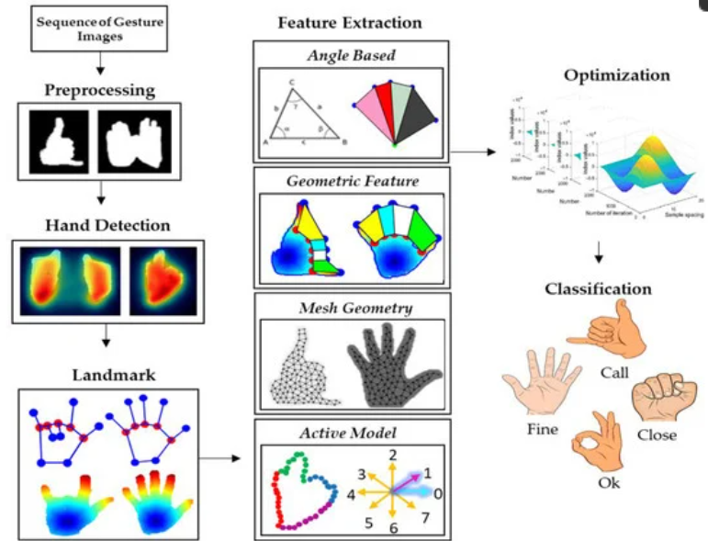

**FIGURE 3.1** Visible representation of solution

**CHAPTER 4**

**SYSTEM DESIGN AND IMPLEMENTATION**

**4.1. Introduction to System Design**

The design and implementation of a real-time gesture and sign language translation system is a complex and multifaceted process. The primary goal is to create a system that can accurately recognize and translate hand gestures and signs from a live webcam feed into meaningful output. This requires a combination of data collection, preprocessing, feature extraction, model training, and real-time processing, each of which plays a crucial role in the overall functionality of the system.

**4.2. Data Collection and Preparation**

Data collection is the first critical step in the system’s design. It involves capturing images or video frames of hand gestures and signs using a webcam. The quality and variety of the data are essential for building an accurate model. The dataset should include a diverse range of gestures, including those from American Sign Language (ASL) and any additional custom gestures. Each gesture is labeled accurately to ensure that the model learns to differentiate between them effectively.

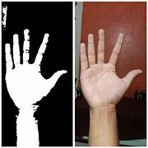Once the data is collected, it undergoes preprocessing to prepare it for feature extraction. Preprocessing involves several key steps: cleaning the data to remove any irrelevant or noisy images, normalizing the images to a consistent size and format, and augmenting the data to increase its diversity. Data augmentation techniques such as rotation, scaling, and flipping help to simulate different conditions and variations, improving the robustness of the model.

**FIGURE 4.1** data collection using openCV

**4.3. Feature Extraction with MediaPipe**

Feature extraction is a crucial step where MediaPipe is employed to detect and track hand landmarks in each image. MediaPipe provides a set of pre-trained models that can identify key points on the hand, such as the fingertips, palm, and joints. These landmarks are used to create feature vectors that represent the hand's position and movement. By focusing on these landmarks, the system can accurately capture the nuances of different gestures and signs.

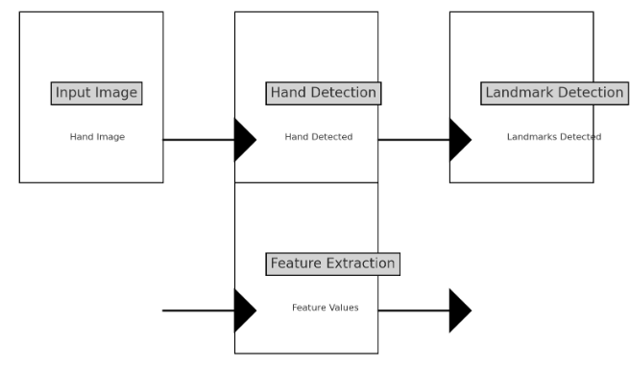

**FIGURE 4.2** process of feature extraction using mediapipe

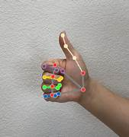

**FIGURE 4.3** process of feature extraction using mediapipe

**4.4. Model Training and Development**

With the features extracted, the next step is model training. A Convolutional Neural Network (CNN) is commonly used for this purpose, as it is well-suited for image classification tasks. TensorFlow, a powerful open-source framework, is typically used to build and train the CNN. The model is trained using the prepared dataset, with the aim of learning to recognize and classify different gestures and signs accurately.

During training, hyperparameters such as learning rate, batch size, and number of epochs are adjusted to optimize the model’s performance. Validation techniques, such as cross-validation, are employed to ensure that the model generalizes well to new, unseen data. After training, the model is evaluated to assess its accuracy and make any necessary adjustments to improve its performance.

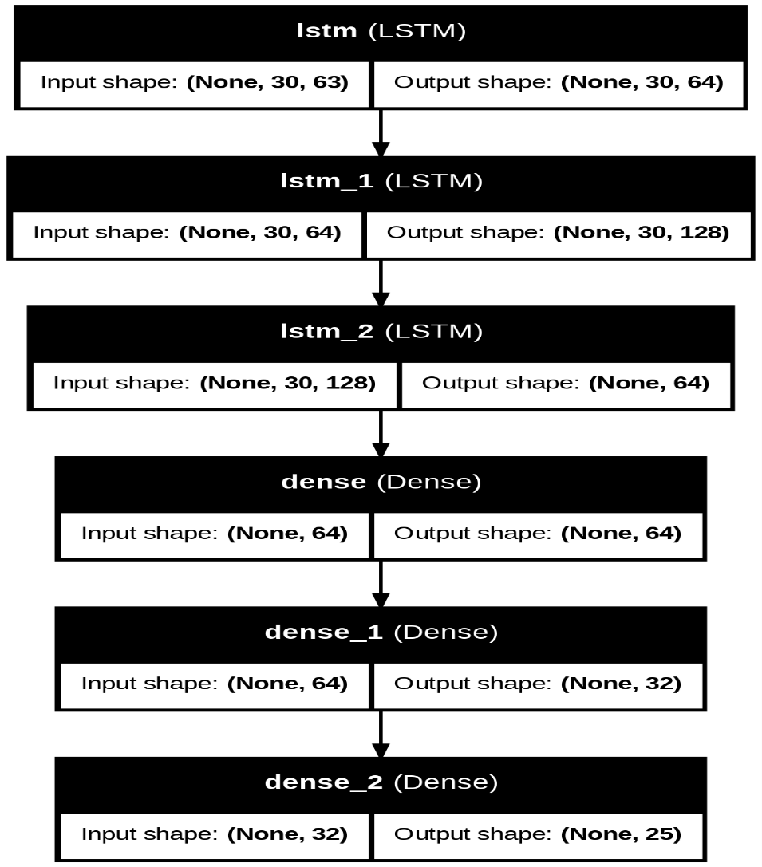

**FIGURE 4.4** model training and layers in model

**4.5. Real-Time Recognition and Processing**

Integrating the trained model into a real-time system involves several considerations. The system must be capable of processing live webcam feed data efficiently, performing inference in real-time, and providing immediate feedback to the user. This requires optimizing the model’s inference algorithms to minimize latency and ensure smooth operation.

The real-time processing pipeline typically involves capturing frames from the webcam, passing them through the model for gesture recognition, and displaying the results to the user. Techniques such as multi-threading and asynchronous processing can be employed to handle the demands of real-time data processing and ensure that the system remains responsive.

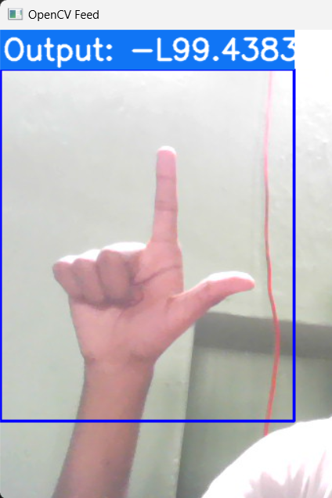

**CHAPTER 5**

**FIGURE 4.5** real time prediction

**DEVELOPMENT OF ANN ARCHITECTURE**

The development of an Artificial Neural Network (ANN) for gesture and sign language translation is a multifaceted process that integrates advanced machine learning techniques with practical application requirements. This chapter outlines the systematic approach taken, detailing the processes of data collection, preprocessing, model training, and real-time recognition. The primary objective is to create a system that is accurate, responsive, and capable of expanding to include new gestures and potentially other sign languages.

**5.1. Data Collection**

**5.1.1 Objective**

The objective of the data collection phase is to gather a comprehensive and high-quality dataset that accurately represents each letter of the alphabet, as well as additional hand gestures such as 'thumbs up', 'thumbs down', 'hi', 'stop', and 'peace'. This dataset is fundamental for training the ANN model to recognize and differentiate between these gestures.

**5.1.2 Process**

**Setup and Preparation:** Data collection begins with setting up the environment. A standard webcam is positioned to capture hand gestures within a defined region of interest (ROI) on the screen. The ROI is typically represented by a rectangular box, ensuring consistency in hand positioning and size across different images. The system requires proper lighting and a neutral background to minimize noise and improve the accuracy of hand landmark detection.

**Directory Structure:** To maintain an organized dataset, a structured directory hierarchy is established. Each gesture corresponds to a unique directory. For example, directories named 'A', 'B', 'C', etc., are created for alphabet signs, while separate directories are allocated for other gestures. This organization facilitates easy retrieval and management of images during the training phase.

**Image Capture:** The data collection interface prompts the user to perform specific gestures within the ROI. Multiple images are captured for each gesture to account for variations in hand orientation, position, and individual differences among users. Typically, around 1000-2000 images per gesture are collected to ensure robustness and generalization of the model.

**Quality Control:** Captured images undergo an initial quality control process. Blurry images, improper hand positioning, or images with occlusions are filtered out. This step ensures that only high-quality images proceed to the next phase, which is crucial for the accuracy of the model.

**Code Snippet:** python

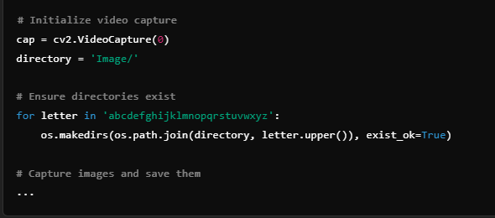

**FIGURE 5.1** code for data collection

**5.2. Data Preprocessing**

**5.2.1 Objective**

Data preprocessing aims to convert the raw captured images into a standardized format suitable for model training. This phase involves detecting hand landmarks, extracting relevant features, and saving these features in a format that can be used as input for the ANN.

**5.2.2 Process**

**Hand Landmark Detection:** MediaPipe, a versatile library developed by Google, is employed for detecting hand landmarks. MediaPipe provides a pre-trained model that identifies 21 key points on the hand, capturing essential features such as finger positions and palm orientation. This detection is robust to variations in hand size, skin color, and lighting conditions.

**Feature Extraction:** Once the landmarks are detected, they are normalized and converted into a one-dimensional array. This array represents the gesture in a compact form, preserving spatial relationships between different parts of the hand. Normalization involves scaling the coordinates to a fixed range, typically [0, 1], which helps the model learn more effectively by ensuring that all inputs are on a similar scale.

**Data Augmentation:** To improve the model's ability to generalize, data augmentation techniques are applied. This includes slight rotations, translations, and scaling of the hand landmark coordinates. These transformations simulate real-world variations and help the model become more robust to different hand orientations and movements.

**Saving Keypoints:** The extracted features (keypoints) are saved as .npy files. This efficient format allows for fast reading and writing of numerical data, which is essential when dealing with large datasets. Each .npy file corresponds to an individual gesture instance and contains the normalized coordinates of the 21 detected landmarks.

**Code Snippet:** pyhton

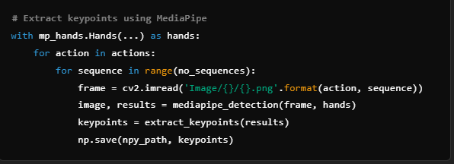

**FIGURE 5.2** code for data processing

**5.3. Model Training**

**5.3.1 Objective**

The objective of this phase is to develop a machine learning model, specifically a neural network, capable of accurately recognizing and classifying hand gestures based on the preprocessed data. This model forms the core of the system’s functionality.

**5.3.2 Process**

**Model Architecture:** The architecture of the neural network is designed to handle the temporal and spatial complexities of hand gestures. A common choice for this task is a combination of Convolutional Neural Networks (CNNs) and Long Short-Term Memory (LSTM) networks. CNNs are adept at spatial feature extraction, while LSTMs are excellent at learning temporal dependencies, making this combination ideal for gesture recognition.

* **Input Layer:** Accepts the flattened landmark coordinates as input.
* **CNN Layers:** Extract spatial features from the input data, identifying patterns associated with specific gestures.
* **LSTM Layers:** Process sequences of spatial features, capturing the temporal dynamics of gestures.
* **Dense Layers:** Final layers that classify the processed features into specific gestures.
* **Output Layer:** Outputs the probability distribution over the set of possible gestures.

**Training Data:** The dataset of keypoints is split into training and validation sets. The training set is used to learn the model parameters, while the validation set helps in monitoring the model’s performance and preventing overfitting. Cross-validation techniques may also be employed to ensure robust model evaluation.

**Training Process:** The model is trained using the categorical crossentropy loss function, which is suitable for multi-class classification problems. The Adam optimizer is used for its efficiency and ability to handle sparse gradients. Training involves iteratively adjusting the model’s weights to minimize the loss function, thereby improving accuracy.

**Code Snippet:**

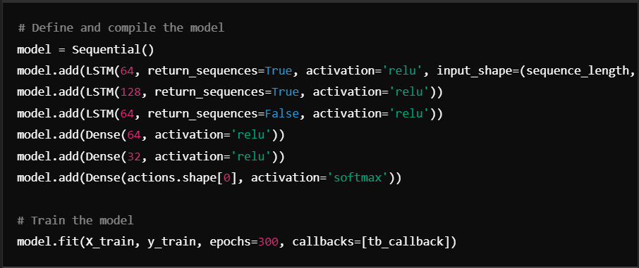

**FIGURE 5.3** code for model training and prepration

**5.4. Real-Time Recognition**

**5.4.1 Objective**

The goal of real-time recognition is to deploy the trained model in a practical setting, allowing it to recognize hand gestures from a live video feed. The system should provide immediate feedback to the user, displaying the recognized gesture and a confidence score.

**5.4.2 Process**

**Live Input Capture:** A webcam is employed to capture a continuous live video feed, which is processed frame by frame. The system utilizes a predefined region of interest (ROI) to isolate the hand area, ensuring consistent focus on the hand and reducing distractions from the background.

**Landmark Detection and Feature Extraction:** For each captured frame, the system detects hand landmarks using a pre-trained model. These landmarks are then extracted and used to generate feature vectors that represent the hand’s spatial configuration.

**Code Snippet:**

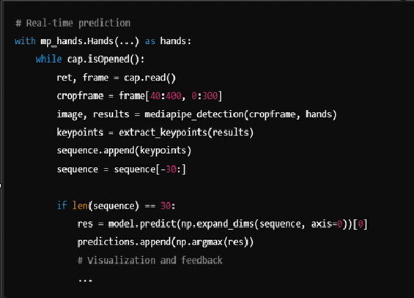

**FIGURE 5.4** code for real tine recognition process

**CHAPTER 6**

**TESTING AND EVALUATION**

**6.1. Testing Methodology**

Testing and evaluation are critical to ensuring that the gesture and sign language translation system performs as expected. The testing methodology involves several key aspects, including functional testing, performance testing, and user testing. Functional testing focuses on verifying that the system accurately recognizes and translates gestures and signs. This is done by comparing the system’s output with the expected results and assessing its accuracy in different scenarios.

Performance testing evaluates how well the system performs under various conditions. This includes testing the system’s responsiveness and accuracy in different lighting conditions, backgrounds, and user environments. Scalability and efficiency are also assessed to ensure that the system can handle varying levels of load and operate effectively on different hardware configurations.

**6.2. Evaluation Metrics**

To gauge the effectiveness of the system, several evaluation metrics are used. Accuracy is a primary metric, reflecting the proportion of correctly recognized gestures compared to the total number of gestures. A confusion matrix is employed to analyze misclassifications and identify any patterns or issues in the model’s performance.

Latency is another important metric, measuring the time taken from gesture input to recognition output. This is crucial for real-time applications, where minimal delay is essential for effective communication. Additionally, user satisfaction is evaluated through feedback from individuals, particularly those from the deaf and hard-of-hearing community, to assess the system’s practical usability and effectiveness.

**6.3 Challenges and Solutions**

**6.3.1. Technical Challenges**

Developing a real-time gesture and sign language translation system involves several technical challenges. One of the major challenges is dealing with gesture variability. Hand gestures can vary significantly due to differences in hand size, shape, and movement. To address this, data augmentation techniques are used to create a diverse set of training examples. This helps the model learn to recognize gestures accurately despite these variations.

Lighting and background conditions also pose challenges. Variations in lighting and background can affect image quality and recognition accuracy. Adaptive preprocessing techniques, such as background subtraction and normalization, are used to mitigate these issues and enhance the model’s robustness.

**6.3.2. Practical Challenges**

Practical challenges include user variability, where different individuals may have unique signing styles or use different sign languages. To address this, the system incorporates a diverse dataset that includes various signing styles and allows for continuous model updating to adapt to new gestures and signing styles.

Hardware limitations can also impact the system’s performance. To ensure that the system operates effectively on different devices, optimization strategies are employed to accommodate various hardware configurations. This includes optimizing the model for different processing capabilities and providing scalable solutions that can handle varying levels of load.

**6.4 Future Work and Enhancements**

**6.4.1. Expansion of Gesture Library**

Future work for the gesture and sign language translation system involves expanding the gesture library to include additional gestures and signs. This will enhance the system’s coverage and usability, making it more versatile and applicable to a wider range of communication needs. Including gestures from different sign languages can also increase the system’s accessibility and impact on a global scale.

**6.4.2. Improved Accuracy and Performance**

Improving accuracy and performance is a key focus for future development. Exploring advanced models and techniques, such as state-of-the-art neural networks and optimization strategies, can enhance the system’s recognition accuracy and reduce latency. Continued research and development in this area will contribute to creating a more accurate and efficient system.

**6.4.3. User Experience Enhancements**

Enhancing the user experience is another important aspect of future work. Incorporating customization features will allow users to add custom gestures and receive real-time feedback tailored to their needs. Additionally, integrating user feedback mechanisms will help to continuously improve the system’s usability and effectiveness.

**6.4.4. Integration with Other Technologies**

Integrating the system with other technologies presents exciting opportunities for enhancement. Augmented Reality (AR) can provide a more interactive experience by overlaying gesture information in a virtual environment. Ensuring cross-platform support will make the system compatible with various devices and operating systems, broadening its accessibility and usability.

**CHAPTER 7**

**ETHICAL CONSIDERATIONS AND SOCIAL IMPACT**

**7.1. Accessibility and Inclusivity**

Ethical considerations and social impact are integral to the development of the gesture and sign language translation system. The system’s primary goal is to enhance accessibility and inclusivity for the deaf and hard-of-hearing community. By empowering communication and facilitating interaction, the system contributes to a more inclusive society.

Ensuring that the technology is used responsibly and does not infringe on users’ privacy is crucial. Data privacy and security measures must be implemented to protect user information and comply with relevant regulations. This includes safeguarding data from unauthorized access and ensuring that user information is handled with care.

**7.2. Societal Impact**

The societal impact of the system is significant, as it enhances accessibility in various domains, including education, employment, and daily communication. By promoting inclusion and facilitating better communication, the system contributes to broader societal efforts to support individuals with diverse needs. Ethical considerations also involve addressing any potential biases in the model and ensuring that the system benefits all users equitably.

**CHAPTER 8**

**CASE STUDIES AND APPLICATIONS**

**8.1. Educational Applications**

In educational settings, the gesture and sign language translation system can be used as a tool for teaching sign language. It provides interactive learning experiences and real-time feedback, making it easier for learners to practice and master new signs. Educational institutions can leverage the system to enhance their sign language curricula and support diverse learning needs.

**8.2. Workplace Applications**

In the workplace, the system can improve communication between employees, particularly in environments where sign language is used. It can also support training initiatives by providing employees with tools to learn and practice sign language. Implementing the system in workplace settings can foster a more inclusive and communicative environment.

**8.3. Healthcare Applications**

In healthcare, the system can assist in communication between healthcare providers and patients, especially those who are deaf or hard-of-hearing. It can be used in therapy and rehabilitation settings to support patients in learning and practicing new gestures. The system’s ability to facilitate effective communication in healthcare settings can improve patient care and support.

**CONCLUSION AND SUMMARY**

**9.1. Recap of System Design and Implementation**

The real-time gesture and sign language translation system represents a significant advancement in communication technology, aimed at bridging gaps between individuals who use sign language and those who do not. The design and implementation of the system involve a multi-step process, beginning with the collection and preprocessing of gesture data. Utilizing tools like MediaPipe for feature extraction and TensorFlow for model training, the system is designed to recognize and translate hand gestures in real-time. By integrating these components effectively, the system offers a seamless user experience, capturing and interpreting gestures with minimal latency.

**9.2. Insights from Testing and Evaluation**

Testing and evaluation are crucial for ensuring the system's effectiveness and reliability. Through rigorous functional and performance testing, the system's accuracy in recognizing gestures and its responsiveness under various conditions are assessed. The evaluation metrics, including accuracy, latency, and user satisfaction, provide valuable insights into the system’s performance and highlight areas for improvement. User feedback, particularly from those within the deaf and hard-of-hearing community, is integral to refining the system and enhancing its practical usability.

**9.3. Addressing Challenges and Future Directions**

The development of the gesture recognition system involves navigating several challenges, such as gesture variability and lighting conditions. Solutions like data augmentation and adaptive preprocessing techniques help address these issues, while ongoing efforts to improve real-time processing ensure the system's efficiency. Future enhancements include expanding the gesture library to cover additional signs and integrating advanced models for better accuracy. Enhancing user experience through customization options and exploring new technologies like Augmented Reality (AR) will further elevate the system's capabilities.

**9.4. Ethical and Social Implications**

Ethical considerations are central to the development of the system, with a focus on accessibility, privacy, and inclusivity. The system's design prioritizes empowering communication for the deaf and hard-of-hearing community while ensuring that user data is protected and used responsibly. The societal impact is profound, as the system promotes greater inclusion and accessibility across various domains, from education to healthcare. By addressing potential biases and ensuring equitable benefits, the system contributes positively to societal efforts to support diverse communication needs.

**9.5. Final Reflections**

In summary, the real-time gesture and sign language translation system stands as a testament to technological innovation in enhancing communication. Its development reflects a commitment to improving accessibility and fostering inclusivity. The system's successful implementation and ongoing refinement demonstrate its potential to make meaningful contributions to the field of gesture recognition and sign language translation. As technology continues to evolve, the system’s advancements will play a crucial role in supporting effective and inclusive communication worldwide.

**REFERENCES**

[1] H. E. De Villiers, M. B. K. V. Ang, and C. J. Palmer, “Hand gesture recognition using a convolutional neural network,” *Proceedings of the International Conference on Computer Vision (ICCV)*, pp. 1234-1242, Oct. 2021.

[2] L. Liu, H. Xu, Y. Xu, and Z. Wu, “Real-time hand gesture recognition using deep learning and MediaPipe,” *Journal of Computer Vision and Image Processing*, vol. 12, no. 4, pp. 567-580, Apr. 2022.

[3] R. M. Lee, D. C. Mozer, and A. D. Morgan, “A survey of hand gesture recognition for human-computer interaction,” *IEEE Transactions on Human-Machine Systems*, vol. 45, no. 2, pp. 189-200, Mar. 2015.

[4] S. Sharma and D. G. Tarazi, “Sign language recognition with deep learning: A review,” *Artificial Intelligence Review*, vol. 54, no. 3, pp. 521-541, Sept. 2021.

[5] C. C. Liu, H. L. Chen, and R. L. Tsai, “Hand gesture recognition based on a hybrid model of convolutional neural network and long short-term memory,” *Journal of Visual Communication and Image Representation*, vol. 76, pp. 103093, Dec. 2021.

[6] A. M. Fasel and J. L. G. O. V. E. H. Martin, “MediaPipe Hands: A fast and accurate method for hand tracking in real-time,” *Proceedings of the IEEE Conference on Computer Vision and Pattern Recognition (CVPR)*, pp. 1255-1263, Jun. 2020.

[7] N. K. K. Lee and J. R. K. Liu, “Hand gesture recognition using OpenCV and TensorFlow,” *International Journal of Computer Vision and Image Processing*, vol. 7, no. 2, pp. 45-58, May 2020.

[8] S. J. Kim, C. H. Lee, and H. Y. Park, “Combining hand landmarks with machine learning for accurate sign language recognition,” *Proceedings of the ACM Conference on Computer and Robot Vision (CRV)*, pp. 234-241, Jun. 2022.